SED 2019
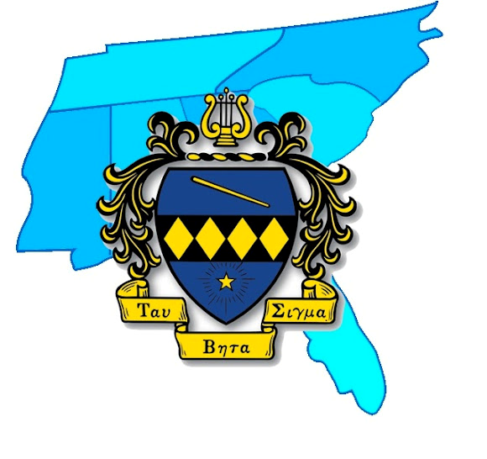
CHAPTER AWARDS PACKET
Due: March 20, 2019
For all of these awards, chapters are encouraged to submit photos and videos alongside their applications!
SED Chapter Excellence Award
Given in recognition of a chapter’s achievement of excellence in all aspects of the Sorority, including service, membership, leadership, joint relations, and fellowship.
For consideration for the SED Chapter Excellence Award, your responses to the other questions in this packet will be considered in addition to other submissions and involvement such as:
- MEP
- Constitution
- Budget
- Participation at the District Level
- Participation at the National Level
- Focus on Five Projects
Additional Questions:
How does your chapter foster positive relationships among its members?

How does your chapter promote positive joint relations with your Kappa Kappa Psi counterpart (if applicable)?

If there is anything else you would like for us to consider that has not been covered in this packet, please describe it here:

Leadership Development Award:
Given in recognition to a chapter that has made great strides in developing the leadership of its members, improving them not only as sisters, but members of the greater community.
Exceptional chapters will showcase aspects such as:
- Participation at the district and national level: such as attending conventions, conferences, other chapters’ events, KKPsi events, and contributing to other programs and committees
- Members involved in band leadership
- Chapter development initiatives, such as professional development workshops, chapter retreats, other presentations/workshops, and leadership opportunities for sisters within the chapter
Chapter Name and University:

What leadership positions do your members hold in your university bands?

How do your members display those “traits of conduct, thought, and idealism?”

How do you promote personal growth in your active membership?

How have individuals contributed/participated on a district/national level?

How has your chapter empowered women in the band profession and in other areas?

Art of Music Award
Given in recognition of a chapter’s efforts to promote music and musicianship within their chapter, bands, and community.
Exceptional chapters will showcase aspects such as:
- Chapter music events and performances
- Music-based service projects
- Efforts to support the chapter’s university bands and music, such as fundraising for music charities, projects engaging the public with music, and social media promotionad
- Sisters furthering their own and others’ musical abilities
- Other musicianship initiatives
Chapter Name and University:
Number of Active Chapter Members:
Number of Actives who are music majors/minors:

How do you encourage musicianship within your chapter?

Does your chapter host any musical events, such as: recitals, musicales, competitions, etc.? If so, please describe.

How does your chapter serve your university bands?

How has your chapter engaged and promoted music “among the listening public everywhere?”
Community Development Award
Given in recognition of a chapter’s engagement with the general public, supporting their bands through development and improvement of their community.
Exceptional chapters will showcase aspects such as:
- Participation in District and National programs
- Engagement with the chapter’s local community, including projects with schools, scouting troops, community bands, etc.
- Other public service projects, such as donation drives or environmental clean ups
- Going above and beyond from just directly serving the university band
Chapter Name and University:
Number of Active Chapter Members:

How has your chapter participated in National Programs?

What aspects of Focus on Five has your chapter achieved?

How has your chapter participated in District Programs?

Does your chapter provide any service to local schools? If so, please describe.

How else has your chapter provided other service that benefits your community?

Joint Relations Award
Given in recognition of a chapter’s efforts cooperate with other musical organizations on their campus, including events focusing on pillars such as fellowship, service, and music.
NOTE: Your chapter is still eligible even if a chapter of Kappa Kappa Psi does not exist on your campus.
Exceptional chapters will showcase aspects such as:
- Joint service projects
- Joint fellowship events
- Joint recitals
- Joint recruitment events
- Healthy relationships with organizations such as Kappa Kappa Psi, Sigma Alpha Iota, Phi Mu Alpha, etc.
Chapter Name and University:
What other musical organizations exist on your campus?

Please describe any service you perform with these organizations.

Please describe any musical events you host with these organizations.

Please describe any membership events you host with these organizations.

Please describe any fellowship events with these organizations.

Please describe any other events you may perform or host with these organizations.

Most Improved Chapter Award
Given in recognition of a chapter’s efforts to improve their functions, evident in their accomplishments in membership, service, music, and elsewhere.

Chapter and University Name:
What is your average membership class size for the past 3 years? (If you take more than one class each year, count all classes in your total for the year.)
What is your average number of active members for the past 3 years?

What steps has your chapter taken to improve its financial standing? Please describe.
(This can include new fundraisers, improved budgets, etc.)

What new service projects has your chapter undertaken in the past year?

How as your chapter improved its efficiency in meetings and other operations?

What new recruitment events has your chapter undertaken in the past year?

Please describe any other improvements your chapter has made in the past year.

