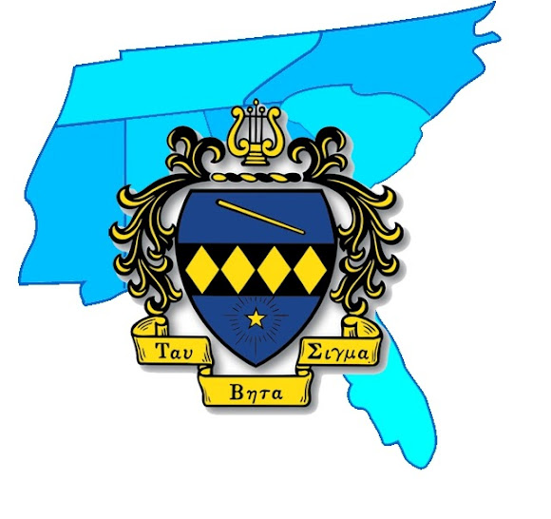
TAU BETA SIGMA- SOUTHEAST DISTRICT CONCERTO COMPETITION RULES AND REGULATIONS
The 2015-2016 TBS SED
Concerto Competition
The Southeast District of Tau Beta Sigma is proud to present the Concerto Competition in order to honor outstanding student musicians on the collegiate level. All undergraduate students are encouraged to submit a video performance for evaluation by our esteemed judges. Concertos must be able to be accompanied by a piano accompanist. Winner must also be available the opening night of SED Convention April 1, 2016 to perform at the joint opening session of convention at Auburn University.
NO PURCHASE, PAYMENT, OR DONATION IS NECESSARY TO ENTER OR WIN THIS COMPETITION. A purchase, payment or donation will not increase or improve your chances of winning.
HOW TO ENTER:
- You must fill out and email an application by March 18, 2016. The application can be found on the Tau Beta Sigma’s Southeast District website at http://tbssed.kkytbsonline.com/concerto-competition/
- Repertoire chosen for the 2016 Concerto Competition must be able to be performed with piano accompaniment. The accompaniment parts must be currently available from some library, publisher, or other lending source. If you have any questions or concerns about your chosen piece, be sure to contact Allison Reagan at sedvpsp@tbsigma.org. Either complete concertos or single movements are eligible for consideration in the 2016 Concerto Competition.
- By March 18, 2016 you must submit a minimum 3 minute video performance of the concerto with or without piano accompaniment. Those who wish to perform an entire concerto must audition with excerpts from at least two movements, a minimum of 2 minutes in each excerpt.
- Winner will be chosen and announced by March 23, 2015. Winner MUST BE able to attend the opening concert of SED Convention, April 1, 2016 hosted in Auburn, AL at Auburn University. A video and audio recording will be sent to the winner afterwards as well as to National Headquarters for archiving.
- A select panel of judges comprised of noted music education professionals will choose the winner. Performances will be judged based on melodic achievement, tempo, and performance quality. Void where prohibited. All federal, state, and local laws and regulations apply.
- The winner will be notified via email and/or voicemail. Entry constitutes permission to use winner’s names and likeness for future advertising and publicity purposes without additional compensation.
- Video performances must be emailed by March 18, 2016 to sedvpsp@tbsigma.org
Any questions or concerns can be emailed to sedvpsp@tbsigma.org

