Tau Beta Sigma— Southeast District

Presents:

**Deadline for applications and recordings is**

**March 18, 2016**

For Official Rules and further information visit   
http://tbssed.kkytbsonline.com/concerto-competition/

For inquiries contact: Allison Reagan

TBS SED Vice-President for Special Projects - sedvpsp@tbsigma.org

Showcase your talent!

Open to all undergraduate students from across the country.

Winner performs at the joint opening session of the 2015-2016 KKY and TBS Southeast District Convention on April 1, 2016!

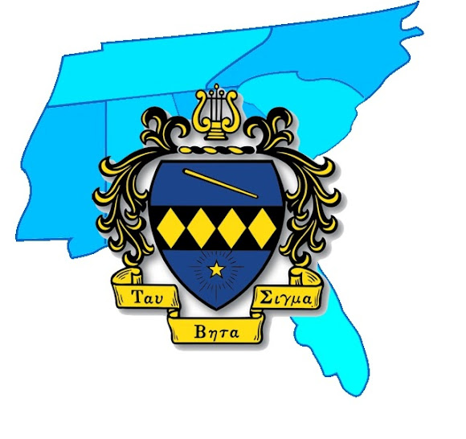

**The 2015-2016 TBS SED**

**Concerto Competition**