*This form is to be submitted by March 18, 2016.

NAME: ___________________________________________________________________________

DATE OF BIRTH:___________________________________________________________________

EMAIL:___________________________________________________________________________

MAILING ADDRESS:_________________________________________________________________ __________________________________________________________________________________________________________________________________________________________________

SCHOOL/UNIVERSITY:______________________________________________________________

INSTRUMENT:_____________________________________________________________________

PRE-APPROVED CONCERTO:__________________________________________________________

By signing below you acknowledge you have read and agree to the Official Rules and Regulations.

SIGNATURE:_______________________________________________________________________

Email this completed form to:

**sedvpsp@tbsigma.org**

All applications AND video recordings must be emailed by March 18, 2016.

Have questions or concerns? Email SEDVPSP@tbsigma.org

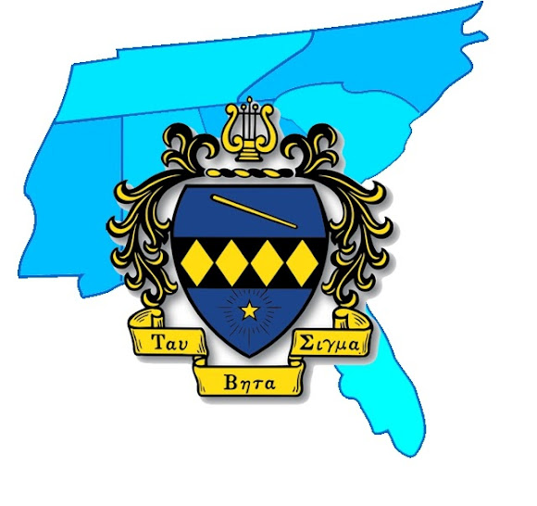

The 2015-2016 TBS SED

Concerto Competition